

**BITI 3533: ARTIFICIAL INTELLIGENCE**

**PROJECT MANAGEMENT**

**Lab 1 – Project Management Framework**

**GROUP WORK**

**PREPARED BY:**

|  |  |  |
| --- | --- | --- |
| **NAMA** | **NO MATRIX** | **GROUP** |
| **NASIRA FEROSIA BINTI ABDUL JABBAR** | **B031910169** | **3BITI S1G1** |
| **SHAMHINIDEVI JAYABALAN** | **B031820098** | **3BITI S1G2** |
| **ANJCHANAA SEENIVASAGAM** | **B031810312** | **2BITI S1G2** |

**PREPARED FOR:**

**PROFESSOR TS. DR. GOH ONG SING**

1. **Select the title of the project which related to IT and AI.**
   * iSafe- Child Abuse Chatbot
   * AI chatbot is an autonomous piece of software capable of interacting and executing human like acts. Chatbots are used widely in customer interaction, advertisement on social networking sites and text messages to the consumer.
2. **Appoint a project manager.** 
   * Nasira ferosia binti abdul jabbar
3. Based on the lecture slides and related information given in ulearn, discuss the **Project Management Framework** as shown in **Figure 1** when relate to **Artificial Intelligence Project Management** and the chosen title as in step no 2.

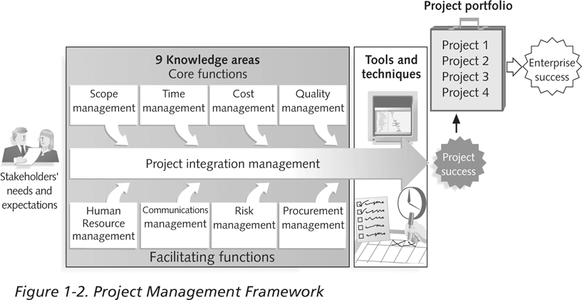

**Figure 1 Project Management Framework**

* + The purpose of project management framework is to map out the process, methods, resources and tools that needed for AI project management from beginning to end. In this project management framework, 9 project management knowledge areas will assist the project manager and team members from various aspects. From these 9-management areas, the most important areas are scope, time and cost. It is because, from these management areas only we can predict project’s success or failure. But when related to AI project management, AI techniques will make our project work better and more accurate. Moreover, AI techniques will increase the speed of decision making by using rule-based process.

**[Project integration management](https://www.workfront.com/project-management/knowledge-areas/integration-management)**

Project integration management is the control of all project components to handling the conflicts facets of the project. An example would be if the project is not on track, you might need to decide between going over the budget or finishing the project late in order to complete it.

**[Project scope management](https://www.workfront.com/project-management/knowledge-areas/integration-management)**

Project scope applies to the overall amount of work to be performed in order to produce a product, service or outcome with defined functions and features. It requires everything that needs to go into a project, as well as what determines its progress.

**Scope of this project is:** Produce a chatbot.

**[Project time management](https://www.workfront.com/project-management/knowledge-areas/integration-management)**

Project time management includes evaluating and creating a plan and timetable for execution of the project. Formalized time control processes provide a buffer for problems like unforeseen roadblocks and timelines.

These time management schedules lay out the activities to be changed and how to assign and handle resources during the project.

**Time management of this project is:** use WBS, milestone etc.

**[Project cost management](https://www.workfront.com/project-management/knowledge-areas/integration-management)**

Project management costs are the method of organizing, forecasting, budgeting and managing project costs. Cost management processes are in place to help project teams plan and control budgets over the life cycle of the project.

### **Cost management by:** Cost estimation, Cost budget, Cost control.

**[Project quality management](https://www.workfront.com/project-management/knowledge-areas/integration-management)**

Project management costs are the method of organizing, forecasting, budgeting and managing project costs. Cost management processes are in place to help project teams plan and control budgets over the life cycle of the project.

### **Quality management happens with these three processes:** Quality planning,

### Quality assurance, Quality control.

**[Project resource management](https://www.workfront.com/project-management/knowledge-areas/integration-management)**

Project resource management in project management includes handling and distributing personnel to the organization, such as budgets, capability and team members.

### **Resource management must provide:** Insights, Priorities, Tracking.

**[Project communications management](https://www.workfront.com/project-management/knowledge-areas/integration-management)**

### Project Management Communications details the protocols and procedures required to ensure that information and documents are correctly gathered, processed and transmitted throughout the project team throughout the life of the project.

### **Communications management primary steps:** Plan communications,

### Manage communications, Control communications.

**[Project risk management](https://www.workfront.com/project-management/knowledge-areas/integration-management)**

### Risk management is a process to mitigate the potential negative impact that unforeseen events may have on project costs, timetables, or other resources.

### Since risk is an inherent aspect of project management, all tasks must be considered from start to finish.

### **Risk management occurs in 5 steps:** Risk planning, Risk identification,

### Risk analysis, Risk response plan, Risk monitoring

**[Project procurement management](https://www.workfront.com/project-management/knowledge-areas/integration-management)**

### Procurement Management is a term that describes the process of managing and optimizing the budget of the project as it relates to the goods, services and resources needed to complete the project.